Final Project ETL

CIS 9440 -Data Warehousing for AnalyticsFinal Project Milestone 3

Due: April 24th,2021

Group Number - 21

Student(s) - Leah Lu, Porfirio Mohabir, Eric Sedaghat, Tori Torsaengtong, Tshering Sherpa

**Utilized Jupyter Notebook and Pandas library to build ETL Pipeline**

**Extraction:**

* Downloaded datasets on local computer from Google BigQuery
* Created two dataframes by reading in datasets “Real estate list.csv” (df) and "median incomes.csv" (df2) using read_csv method



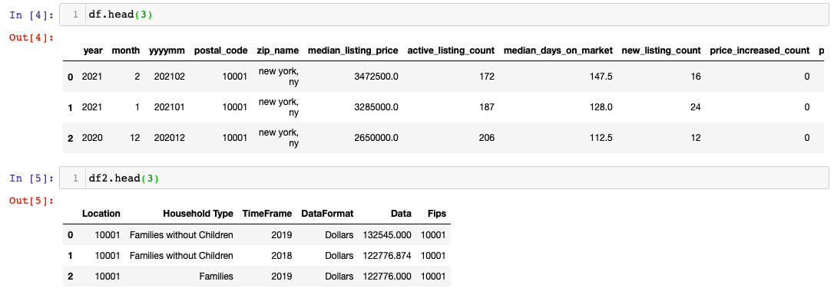

**Transformation:**

* Conducted Data Profiling by executing built-in Pandas methods on both dataframes
  + shape() → length of rows and columns

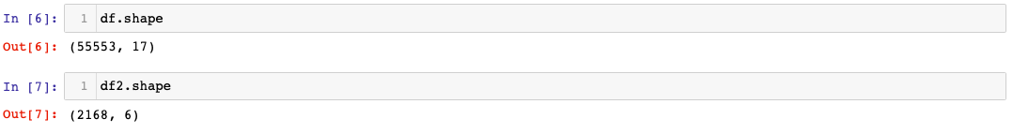

* + info() → results columns, data types, range, non_null count, and memory

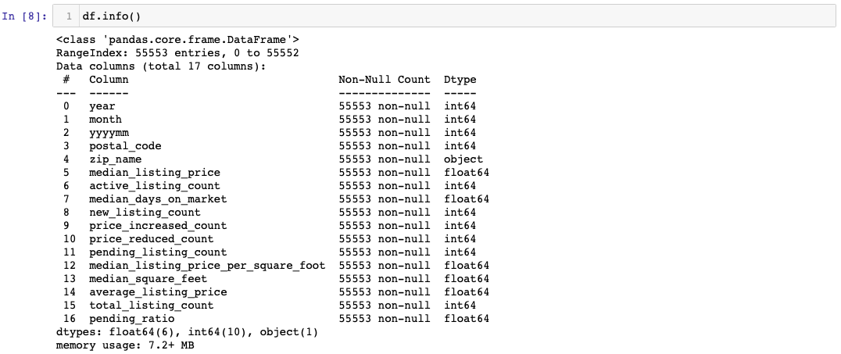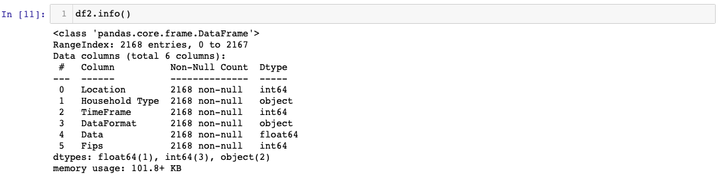

* + describe() → description of data by outputting statistics for each column

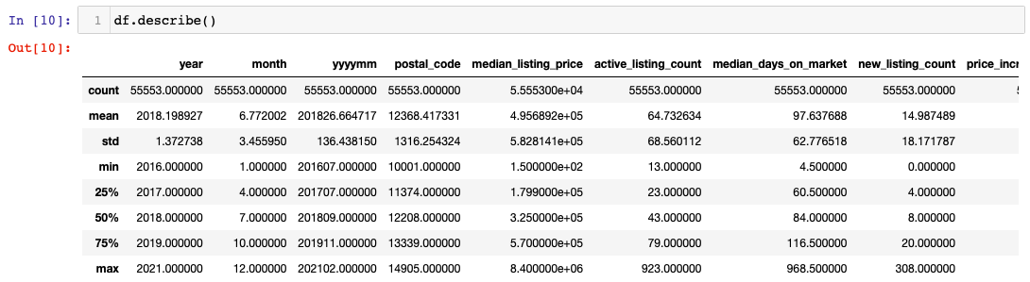

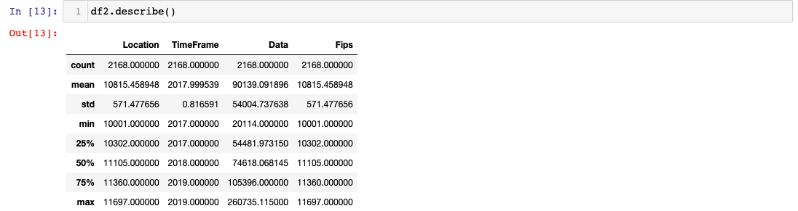

* Data Cleansing
  + Used .isna().any() to search for null values in both dataframes
    - Both df and df2 have **no null values**

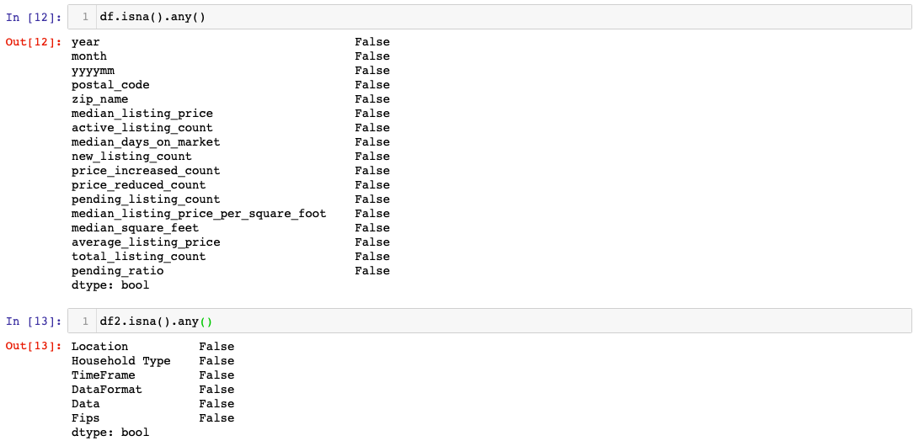

* + Used .duplicated() to search for duplicate rolls in both dataframes
    - Both df and df2 have **no duplicate values**

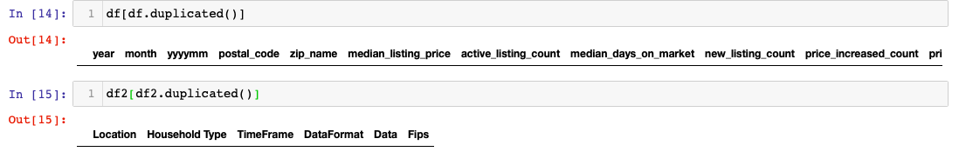

* Data Transformation: includes date, location, household dimensions along with property and income fact tables.
  + Created **date dimension**



* + - Created date_id values starting from 50000

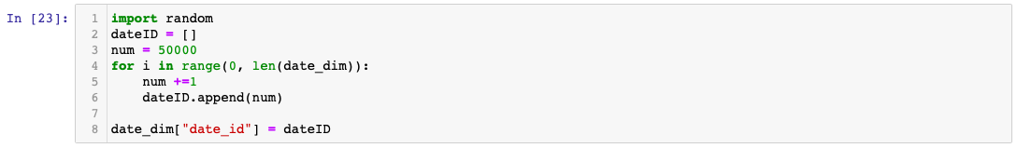

* + - Reordered to put it in a hierarchical order

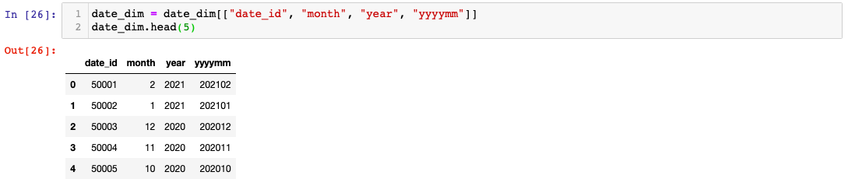

* + - Added a month column to the "median income" dataset so that both "real estate" and "median income" datasets'

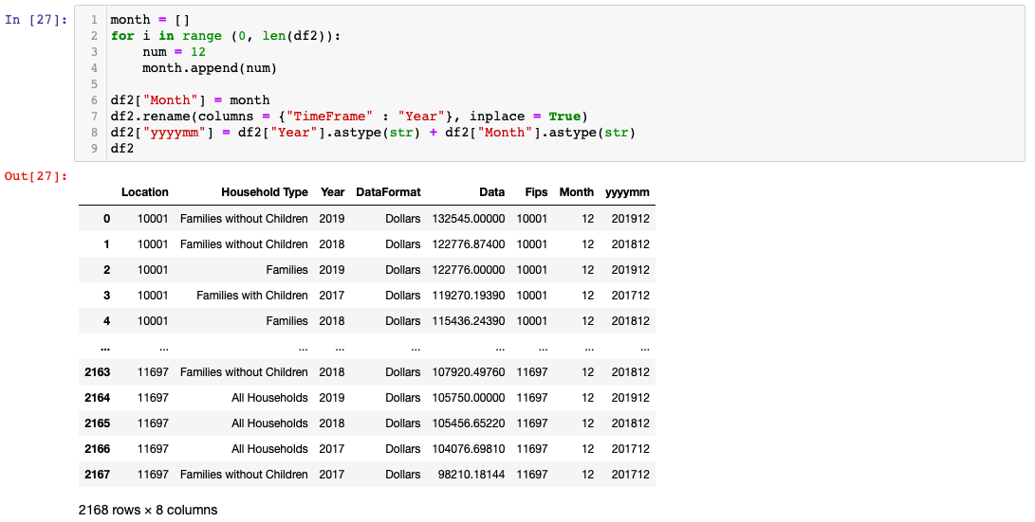

* + Created **location dimension**
    - Changed column name from RegionName to ZipCode and separated the location dimension columns from the main dataset.

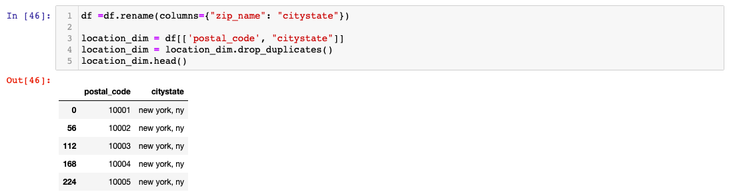

* + - Created a hierarchy for the location dimension. Therefore, we separated the citystate column to a city and a state column.

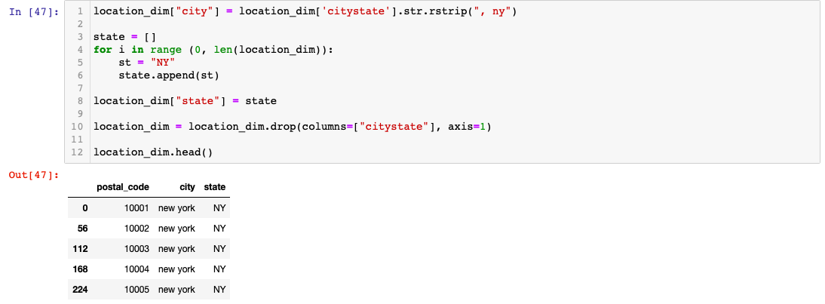

* + - Created location_id for the location dimension.

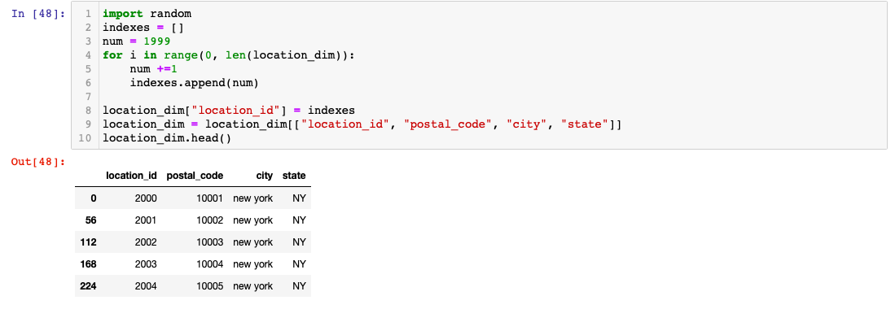

* + Created **household dimension**
    - Created household_id for unique household types.

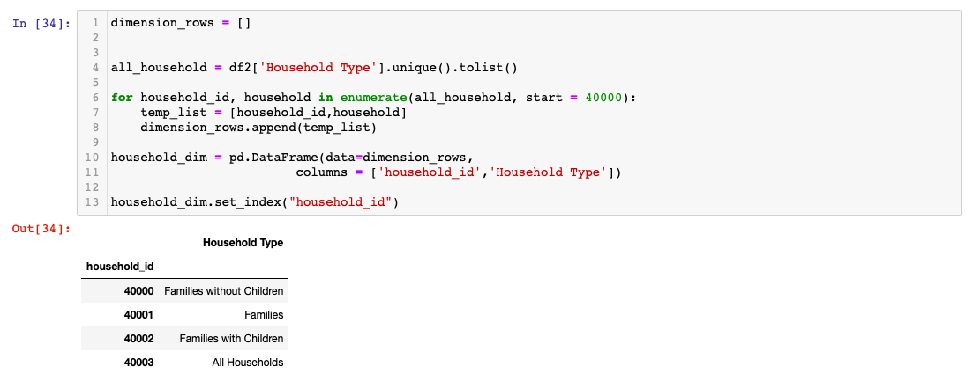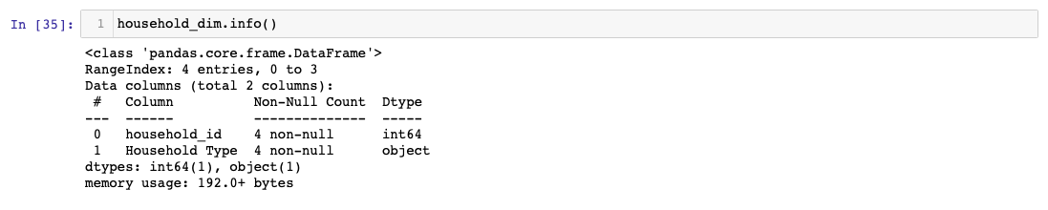

* + Created **property fact table**
    - Created a dataframe with the numerical values needed.

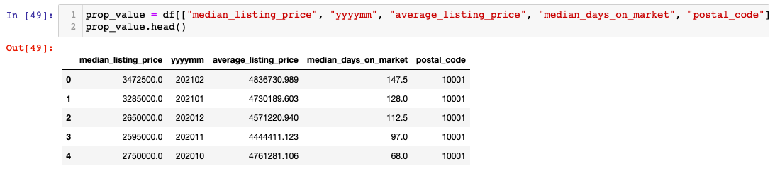

* + - Merged the data and dropped columns that are not being used.

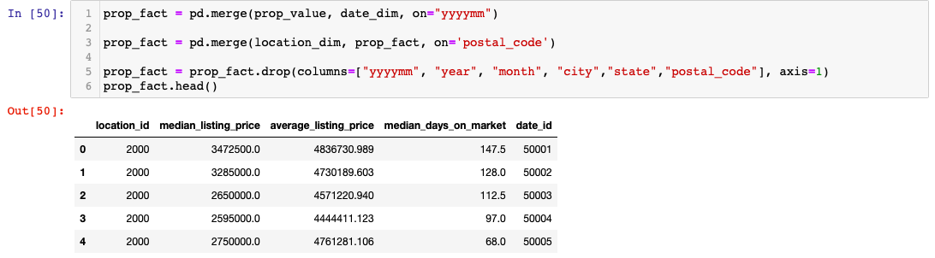

* + Created **income fact table**
    - Created a dataframe with the numerical values needed.

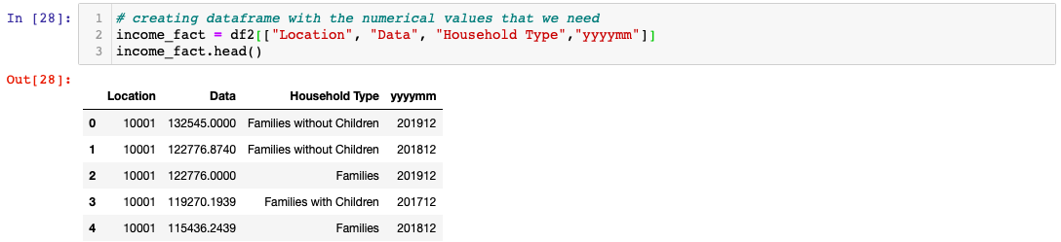

* + - Change the datatype for "yyyymm '' column to match with date_dim for merging.

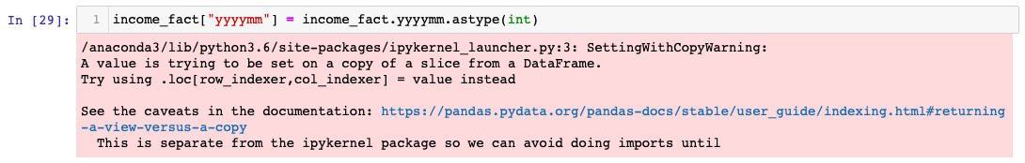

* + - Merged the data and dropped columns that are not being used.

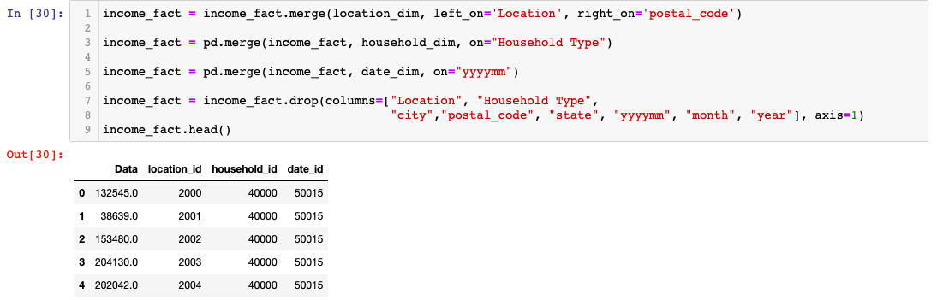

* + - Reordered the columns so that the foreign key columns come before others.

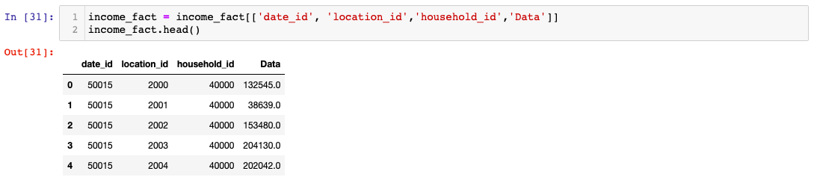

**Load:**

* Connect to Google BiqQuery to begin loading dimensions and fact tables.
  + Assigned dataset ID to variable dataset_id
  + Created a working job using loadJobConfig() method
  + Set autodetect (instance variable) of object “job_config” to Boolean True
  + Set write_disposition (instance variable) of object “job_config” to String “Write_Truncate”

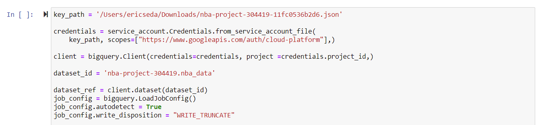

* Loading Date Dimension

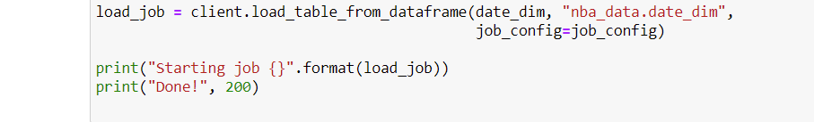

* Loading Location Dimension

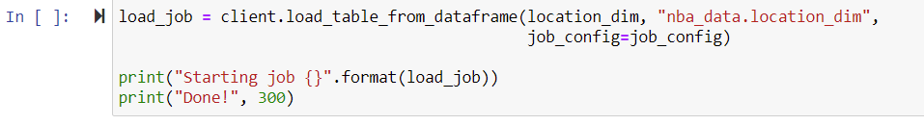

* Loading Property Fact Table

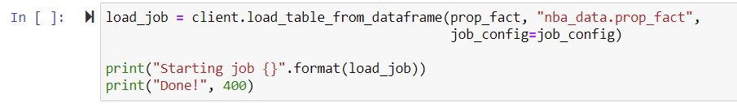

* Loading Household Dimension
  + Renamed “Household Type” → “Household_Type”

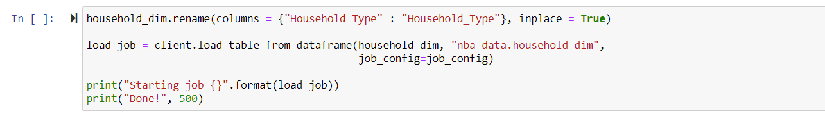

* Loading Income Fact Table

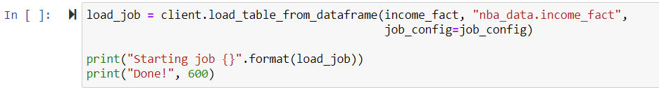

**JOIN STATEMENT**

* Wrote a join statement (to check if the tables link up and work) after uploading the most updated tables to google big query.



